Name: Aditya Gangal

Batch: B

ID: 2021700023

**Aim**: COVID-19 has put huge pressure on health systems. Many hospitals are  running out of oxygen, resulting in preventable deaths and families of hospitalised patients paying a premium for scarce oxygen supplies.with hospitals. Consider the scenario of a government hospital in Mumbai.   You have to  serve patient whose oxygen requirement is least at that moment. Read the input from user. Draw the Gantt chart. Calculate Waiting time, Turn around time, Completion time for each patient as well as average of each time entity.

[I](https://sites.google.com/site/myyclassnotes/homepage1/classnotes/practical-labs/os-lab/os-assignment-i/ass-i)

**Program:**

#include <stdio.h>

#include <stdlib.h>

int findSmallest(int arr[], int size){

int smallest = 0;

for(int i=1;i<size;i++){

if(arr[smallest] > arr[i]){

smallest = i;

}

}

return smallest;

}

double findSum(int arr[], int size){

int sum =0;

for(int i=0;i<size;i++){

sum = sum + arr[i];

}

return sum;

}

int main(){

printf("Enter number of patients");

int n;

scanf("%d", &n);

int sc[n];

int sum =0;

int brSc[n] ;

int brArr[n] ;

int comp[n];

int start[n];

for(int i=0;i<n;i++){

printf("Enter arrival time for patient %d: ", i+1);

scanf("%d", &sc[i]);

printf("Enter time taken for patient %d with oxygen: ", i+1);

scanf("%d", &brSc[i]);

sum = sum+brSc[i];

brArr[i] = 1000;

}

int rn = sc[0];

int rnj = 0;

for(int i=0; i<sum ;i++){

for(int j=0 ; j<n; j++){

if (i==sc[j]){

brArr[j] = brSc[j];

}

}

if (rn==0){

comp[rnj] = i;

rnj = findSmallest(brArr,n);

printf("%d-P%d-",i,rnj+1);

rn = brArr[rnj];

start[rnj] =i;

brArr[rnj] = 1000;

}

rn--;

}

comp[rnj] = sum+sc[0];

printf("%d\n\n",sum+sc[0]);

printf("Process\tWT\tTAT\tCT\n");

for(int i=0;i<n;i++){

printf("%d\t%d\t%d\t%d\n",i+1,start[i]-sc[i],comp[i]-sc[i],comp[i]);

}

printf("The Average waiting time is %lf\n",(findSum(start,n)-findSum(sc,n))/n);

printf("The Average Turn Around Time time is %lf\n",(findSum(comp,n)-findSum(sc,n))/n);

printf("The Average completion time is %lf\n",findSum(comp,n)/n);

return 0;

}

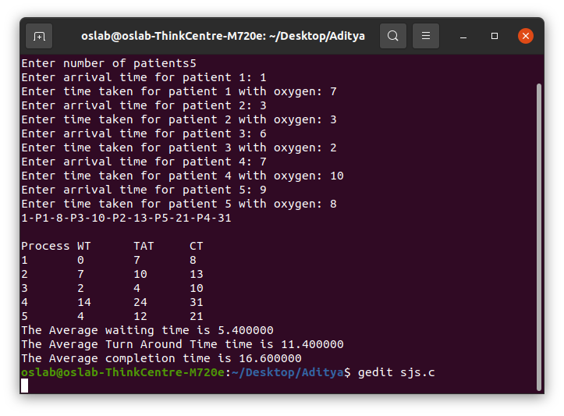**Output:**

**Conclusion: We have learned about how SJS and waiting time, turn around time and completion time .**